修改自 tkg-toolkit刷固件教程 ，感谢教程作者和众多修改者的编辑和付出。该教程只针对AMJ60的pcb，其它pcb大同小异。

以下分两部分，第一部分为固件刷新，第二部分是配列编辑。

第一部分固件刷新

开始前的准备：下载杰少群（群号53913100）的tkg-toolkit-master-修改版.rar ，并解压缩。(下载上传最新为好)
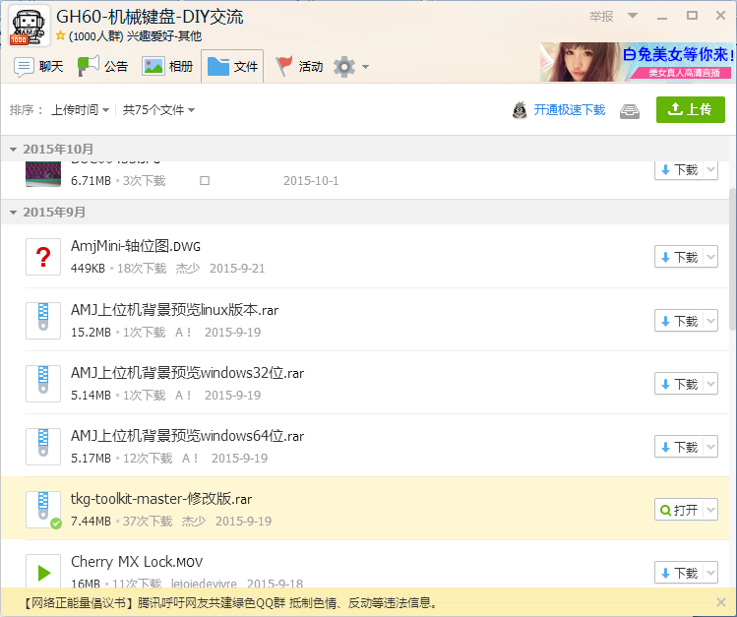

第一步:转换usb协议 打开解压好的 tkg-toolkit-master文件夹，打开/windows/tool. 右键点击zadig_2.1.2，以管理员身份运行。
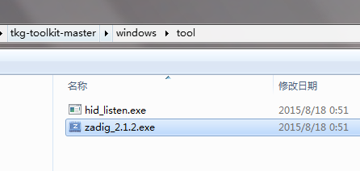
连接AMJ60 PCB，按两秒背面的按钮（key），松开，等几秒。
此时，点击options.选择list all。然后出现下图
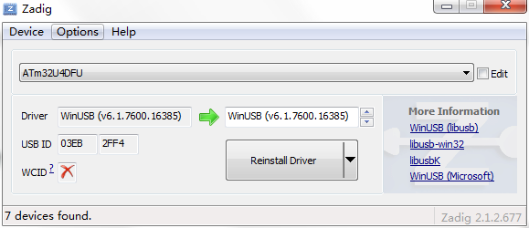
点击Reinstall Driver。10来秒后会提示安装成功。
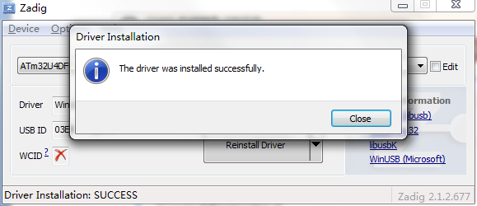
第二步：关闭zadig_2.1.2，打开windows文件夹的setup
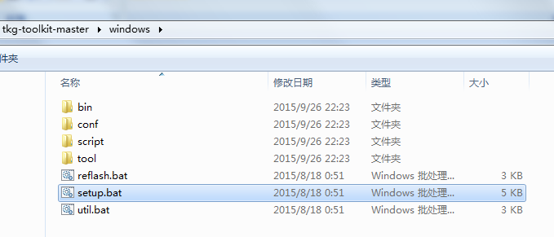

选择AMJ60，即输入数字2或者(具体参照你看到的)，然后一路回车即可，直到对话框关闭。
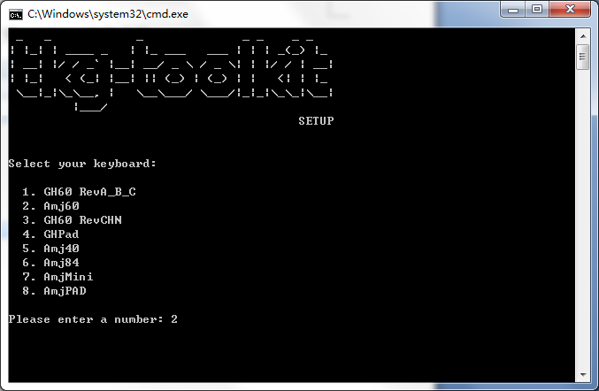
注意，这一步千万不要选错，这是杰少叮嘱的。。。
请根据实际情况判断输入数字。

第三步：更改配列需要eep,不更改配列的话,直接打开reflash即可把自己制作的eep拖到reflash.bat上出现小黑屋然后回车。
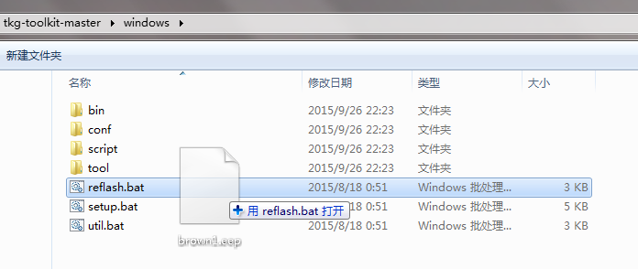
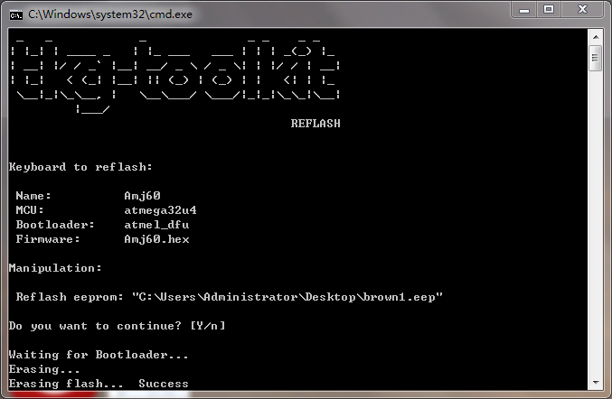
然后到这里配列刷入已经完成了。
如果想重新刷配列，请重新从第一步做起。
补充：假如第一步显示下图的情况是板子全新未装过驱动的缘故，按下图选项直接点击Install Driver即可。其余两步相同。
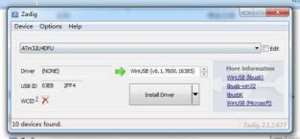
第二部分配列编辑
制作eep文件主要用到以下两个网站地址：
配列代码：
http://www.keyboard-layout-editor.com/#/gists/7353742983dde249f0d9
Eep制作：
http://58.96.180.101/amj/tkg/
http://58.96.180.101/amj/tkg/#help

附上我自己的代码一份。（先略过不用管，后面会提到）
第一层
["Esc","!\n1","@\n2","#\n3","$\n4","%\n5","^\n6","&\n7","*\n8","(\n9",")\n0","_\n-","+\n=",{w:2},"Backspace"],
[{w:1.5},"Tab","Q","W","E","R","T","Y","U","I","O","P","{\n[","}\n]",{w:1.5},"|\n\\"],
[{w:1.75},"Caps Lock","A","S","D","F","G","H","J","K","L",":\n;","\"\n'",{w:2.25},"Return"],
[{w:2.25},"Shift","Z","X","C","V","B","N","M","<\n,",">\n.","?\n/",{w:2.75},"RShift"],
[{w:1.25},"Ctrl",{w:1.25},"Win",{w:1.25},"Alt",{w:6.25},"Space",{w:1.25},"Fn0",{w:1.25},"RAlt",{w:1.25},"RWin",{w:1.25},"RCtrl"]
第二层
["~\n`","F1","F2","F3","F4","F5","F6","F7","F8","F9","F10","F11","F12",{w:2},"Delete"],
[{a:7,w:1.5},"","",{a:4},"↑",{a:7},"","","","",{a:4},"PrtSc","Scroll Lock","Pause\nBreak",{a:7},"",{a:4},"Home","End",{w:1.5},"Fn5"],
[{a:7,w:1.75},"",{a:4},"←","↓","→",{a:7},"","","","","","","","",{w:2.25},""],
[{w:2.25},"","",{a:4},"App","Fn2","Fn1","Fn3",{a:7},"","","",{a:4},"PgUp","PgDn",{a:7,w:2.75},""],
[{w:1.25},"",{w:1.25},"",{w:1.25},"",{a:4,w:6.25},"Fn4",{a:7,w:1.25},"",{w:1.25},"",{a:4,w:1.25},"Delete",{a:7,w:1.25},""]
第三层
[{a:7},"","","","","","","","","","","","","",{w:2},""],
[{w:1.5},"","","","","","","","","","",{a:4},"↑",{a:7},"","",{w:1.5},""],
[{w:1.75},"","","","","","","","","",{a:4},"←","↓","→",{a:7,w:2.25},""],
[{w:2.25},"","","","","","","","","","","",{w:2.75},""],
[{w:1.25},"",{w:1.25},"",{w:1.25},"",{w:6.25},"",{w:1.25},"",{w:1.25},"",{w:1.25},"",{w:1.25},""]

先打开第一个网址，用鼠标点一下enter按钮，其中Top Legend 后面的Enter即按键word，修改这个word就能实现不同的按键功能。先不要急着修改，等我介绍完先，不然你也是白做。
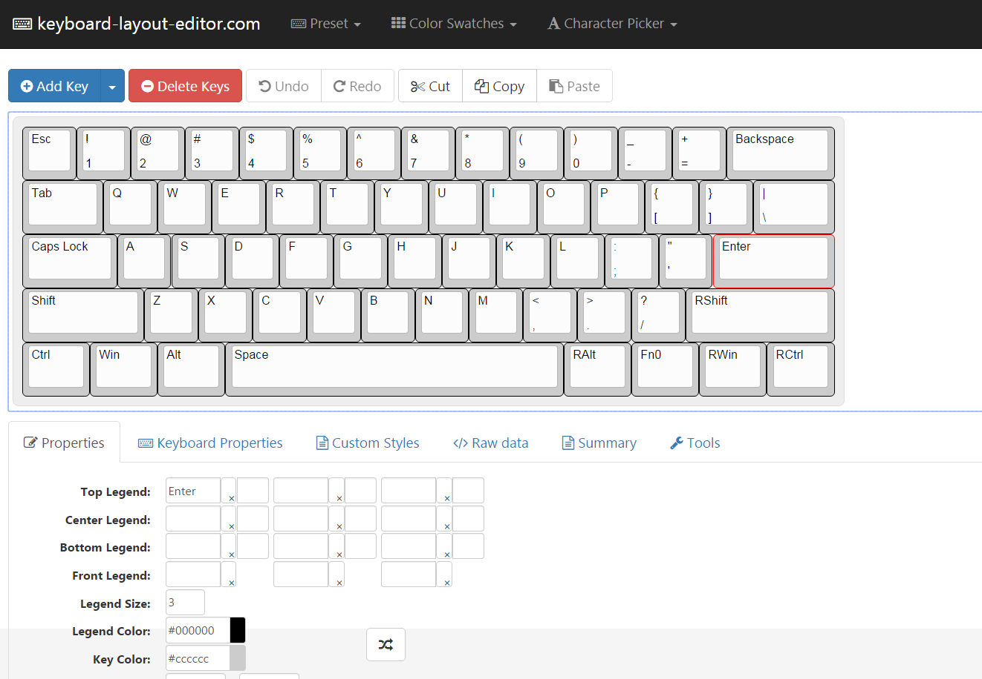

Raw data 这里就是按键代码区，这是制作eep文件的基础
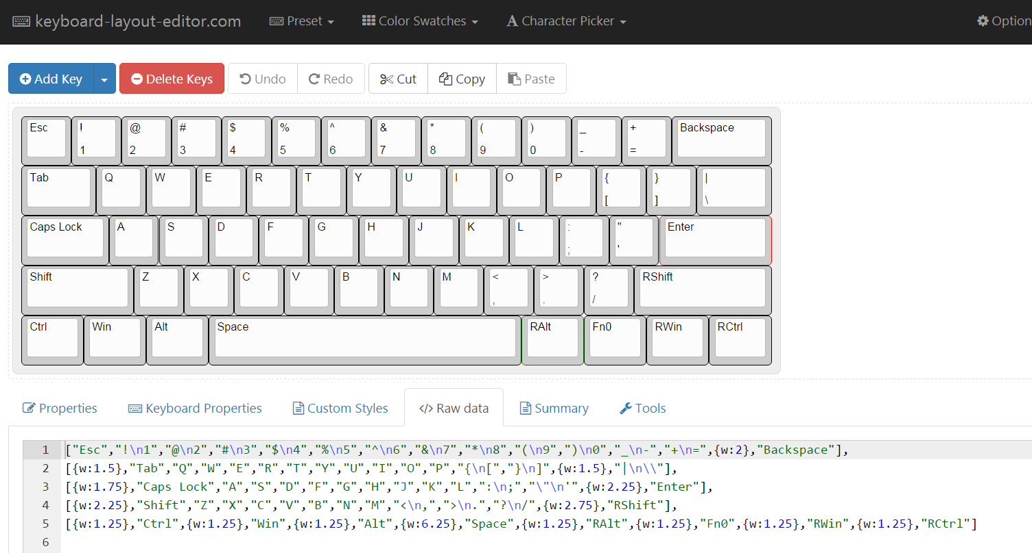
回到properties页面，其中Width是对应的按键长度，X为按键的横向位置，Y为按键的竖向位置。增加按键可以点左上角红色底的Add key，至于怎么修改按键位置请根据GH60可实现的配列自行领悟。
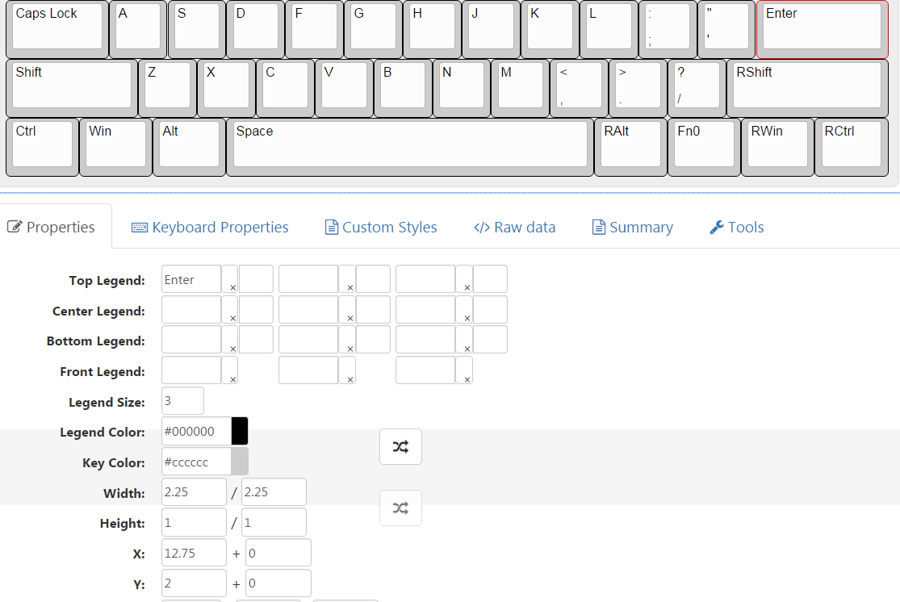
可实现的“按键位置”基本就右图中这些，主要是大键。但按键的个数可以不按照图中配列。（百度搜GH60第一个就有此大图）
怎么配列的问题也是自行领悟，不作解答。因为要解答完花太多篇幅。
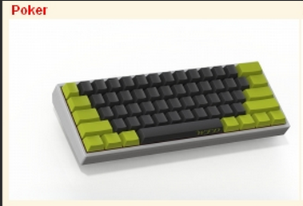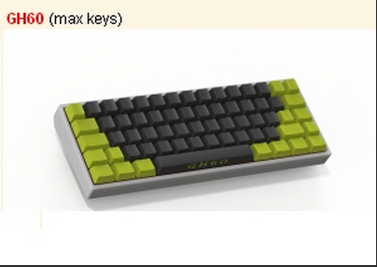

配列例子
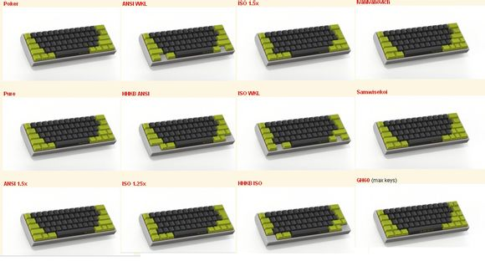
然后再讲解一下代码的问题。
分别将我的三层代码复制粘贴到三个按键编辑网页的Raw Data里，可以得到：

第一层即是我们普通的按键，没有任何组合键情况下的按键
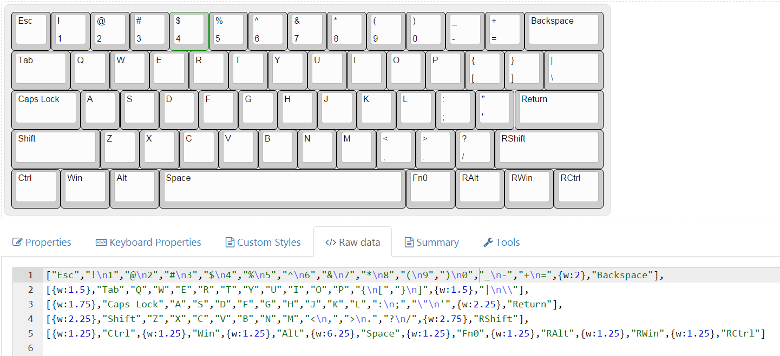

第二层是按住Fn0键后要实现的组合键（自行领悟）,和第一层重复的地方留空。
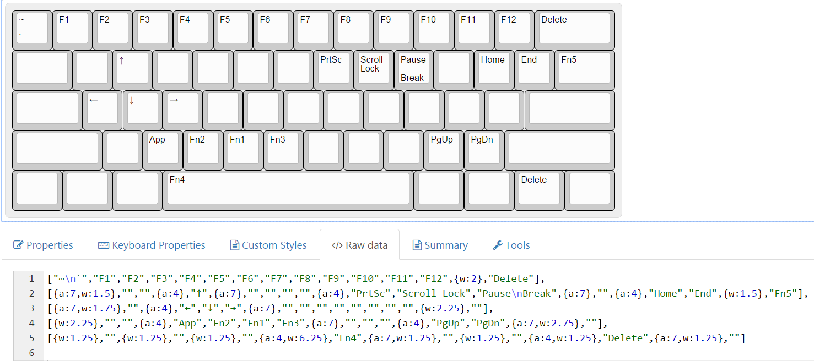

第三层是poker2的fn+空格的切换层功能，方向键功能直接覆盖在原有字母上的。使用方法也是一样，第一次开，第二次关。但是切换有延迟，需要同时按住停顿一秒时间才能成功切换。
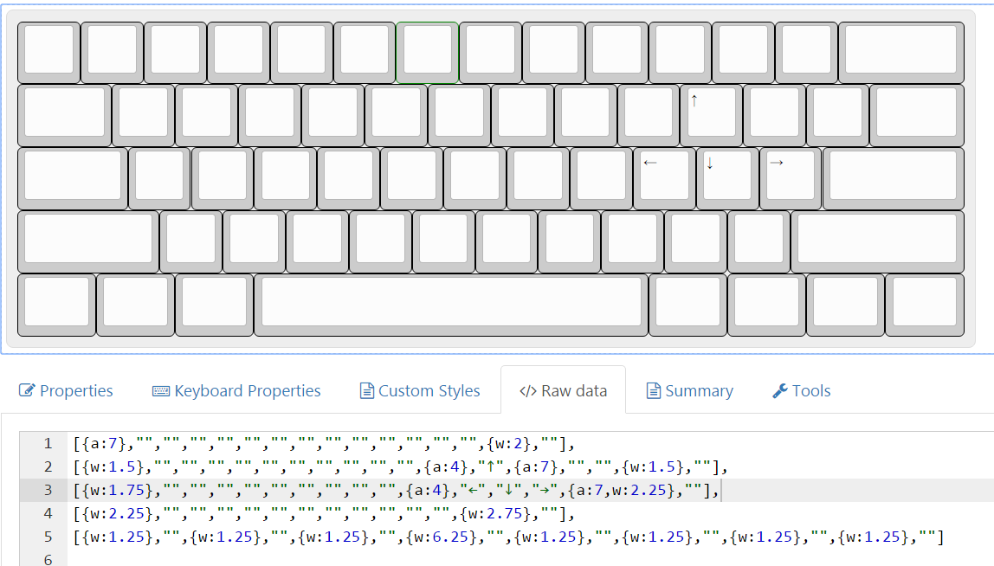

最后是eep制作，打开第二个网址，选择键盘，然后把对应层的代码复制进去，Fn01234的常用功能按下图设置好。Fn请根据实际编辑。
如果代码框右边提示有红字错误，说明你的代码有问题，自己检查下配列，打开按键识别标签（帮助）检查下有什么不对的地方。
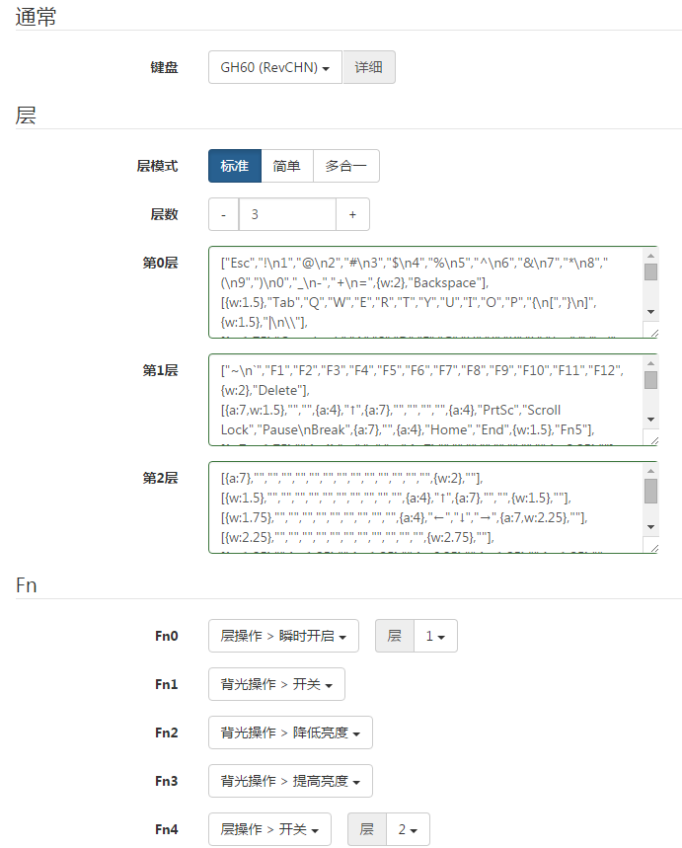
最后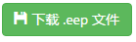。这就是一份eep的制作流程。
这里键盘一项建议选择Amj60，兼容性更强一点，不会出现配列失效，背光无法开启的问题。

然后根据自己的想法，把每一层修改为自己想要的配列和想要的按键功能，改好后分层复制自己的代码到eep制作的网页，改好Fn，下载eep，按第一部分刷入，搞定。

至于细节问题，请多看几遍并自行领悟，不写是因为要花太多口水了。有问题不要问我，问杰少。

Tips：1、请把Enter修改为Return，因为Return才是60里面的enter。
2、示范的代码多出的Fn5键选项可以尝试一下组合键功能，或者加多一层代码做成第四层的开关。

教程完。
感谢所有工具以及本教程的提供者~如有问题请及时联系杰少QQ:37471389 修改于2015/12/25-杰少

